If you split one of the Deductions in Alvys, it will create 2 new deductions totaling the same amount as the original deduction:
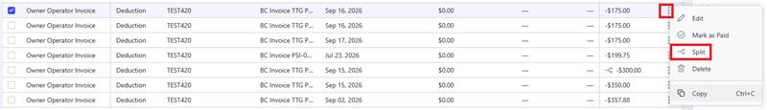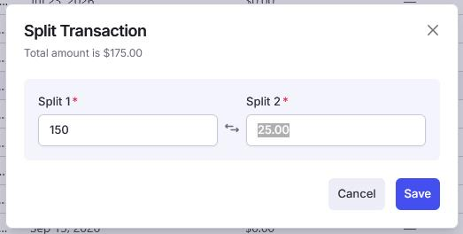
Paying one of the split deductions should then automatically update the related Posted Sales Invoice in BC by reducing the Remaining Amount field by the deduction amoun.
Paying both, will set the Remaining Amount field to zero.

